Fun with Numbers

Story: The Higgledy-Piggledy Spiders

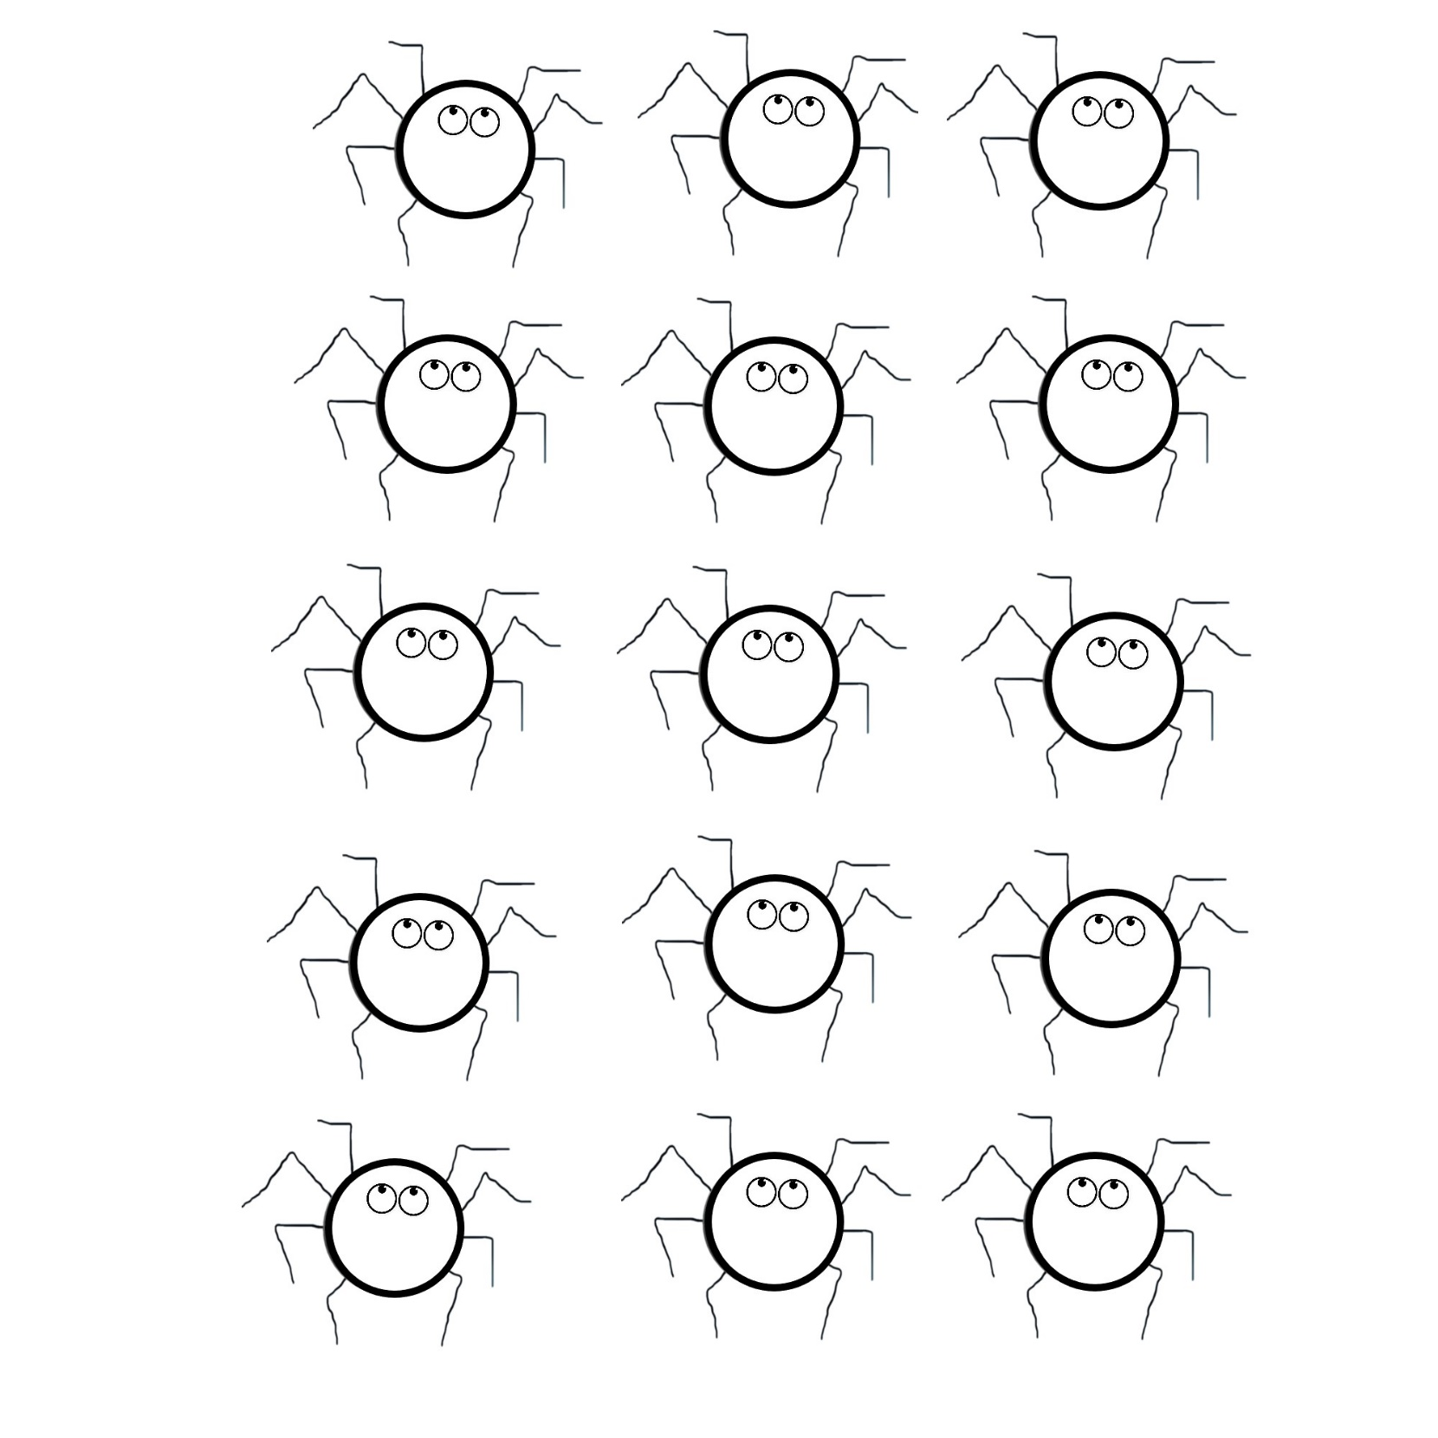

Name:

Can you help me find and colour the spiders with number 15?

166

5

133

8

20

6

17

11

15

15

15

15

15

12

9