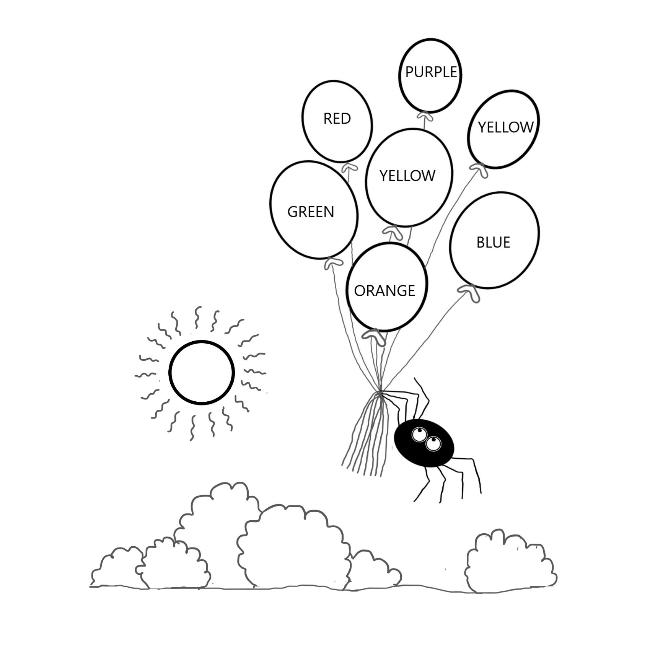

Colour the Balloons

Story: The Higgledy -Piggledy Spiders